Electrical Depth

Introduction

The electrical depth work of this project is broken up into four main sections. The first section follows my lighting design to completion by removing the existing loads from the affected panelboards, connecting the new loads appropriately, resizing the overcurrent protection as well as the feeders servicing the new panelboards, and laying out the branch circuits and controls for each redesigned space. The second section is a study assessing the pros and cons of changing the material of the feeders from copper to aluminum. The third section explores the possibility of incorporating high efficiency transformers into the electrical system and the financial benefits that would result. Finally, a protection device coordination study follows one of the added loads from it’s location at the termination of a branch circuit to the main service, showing whether or not the overcurrent devices are sized properly in relation to each other and the loads they protect. Manufacturers’ data and spec sheets can be located in the Appendix at the end of the report.

Part 1: Branch Circuit Distribution Redesign for New Lighting

For each of the four areas I chose to design, I followed the same process to determine the new loads on the panelboards, and from there I was able to resize feeders and circuit breakers and lay out the new branch circuits. The process for determining the old and new loads was fairly straightforward. First I obtained the panelboards that were affected by following the project drawings. To determine how much of each circuited load from the existing lighting would be affected by the new lighting design, I went through each space and summed up the loads of all the lighting fixtures, accessories, controls etc that would be removed for my new design by utilizing information gathered in the project drawings and specifications. Then I subtracted these loads from the existing panelboard. After the new lighting portion of the project was completed, I computed the loads for the new design and distributed them as evenly as possible over the circuits with loads that had been removed. In every case the new lighting design had a smaller total load than that of the existing lighting needing to be removed, so no additional circuits needed to be added, but the differences in general were quite small and in the grand scheme of things would probably not require much resizing. However, to double check my work following the redistribution of the loads, I took a look at the protective devices and noticed that in every case Cannon Design’s Electrical Engineer oversized the system grossly. After speaking to him I understood that the college had requested such a design to provide for growth as well as any technological changes that would require the utilization of the extra capacity. For the sake of the exercise I sized the overcurrent devices and feeders as we have learned to do in practice, but ultimately l deferred to the judgement of the senior EE in the final panel sizing. The final step was to add circuiting and controls to the existing lighting layout plans. In each space, emergency/life safety lighting is accounted for, and all indoor spaces’ main lighting components have occupancy sensor shutoff when the areas are not in use. In general manual switching methods are applied. For each space, a brief electrical synopsis follows.

Lobby

In the existing power distribution plan, normal branch circuits for lobby lighting are circuited to panel 2LNH1 in positions 2,4,8, and 10. The existing panelboard schedule for Panel 2LNH1 is below, with the affected circuits indicated:
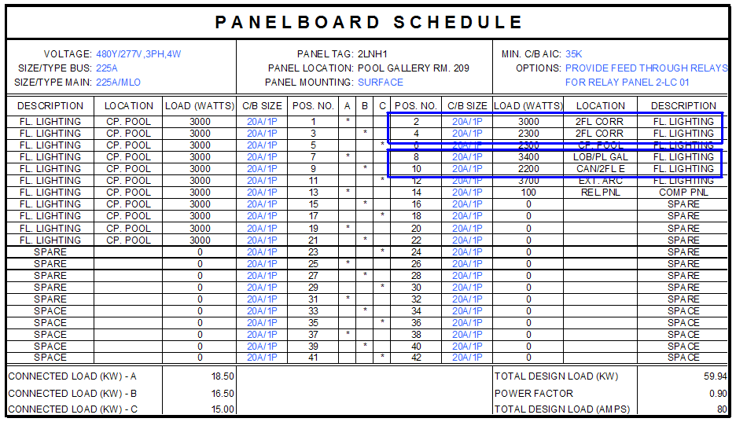

The new panelboard with updated loads:
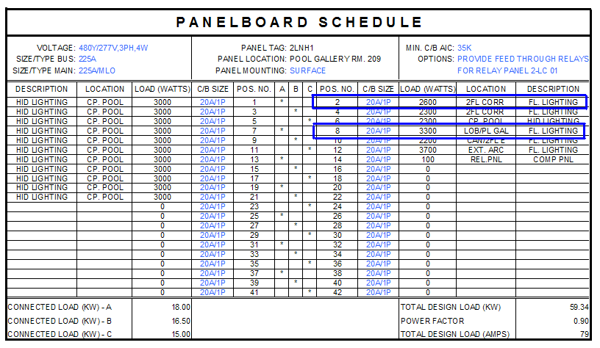
Design Amps (from Panelboard): 79
Circuit Breaker Size: 80A
Feeder Size: (4) 4/0 THW Cu @ 75degC
It’s clear that a smaller panelboard and rating could have been chosen, but to stay in line with the client’s desires the chosen panelboard remains.

Life safety circuits in the original plan were circuited to Panelboard 1LSH3 in positions 2 and 4. The existing panelboard is below:

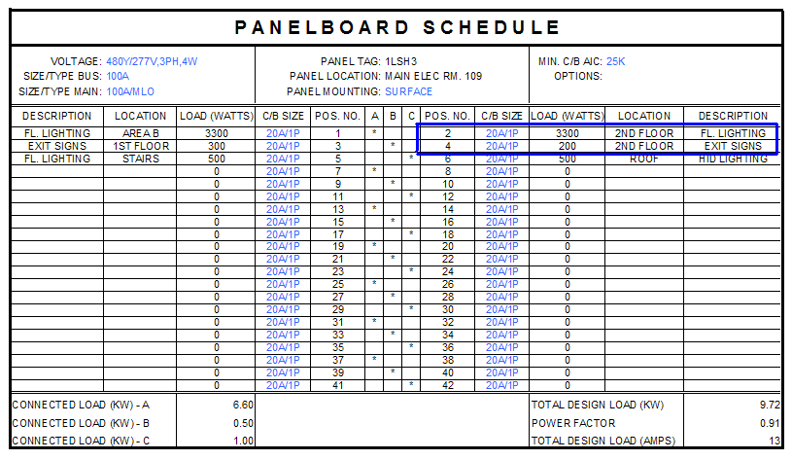

Modified Panelboard:
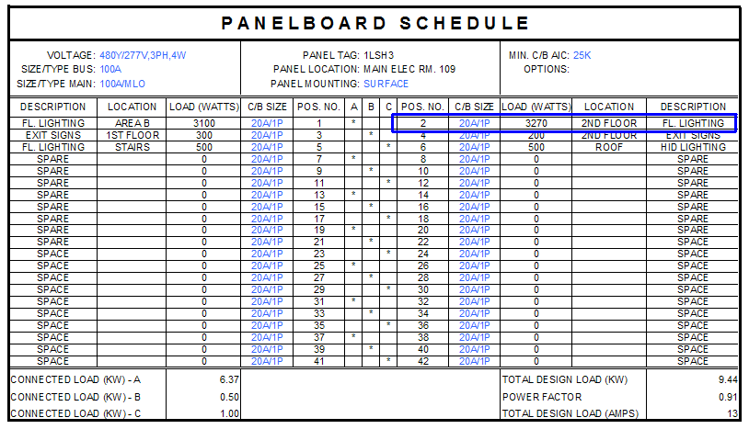
Design Amps: 13
Circuit Breaker Size: 15A
Feeder Size: (4) #12 THW Cu @ 75degC (Could use #14, but #12 is standard)

Again, hardly anything changed as far as loads are concerned.

The final step of laying out the branch circuits and controls is illustrated in the circuiting layout: (For this and all following layouts: Life safety luminaries are indicated by black halfhatching, occupany sensors (figured into the lighting loads) by a diamond with a ‘P’ inscribed.)
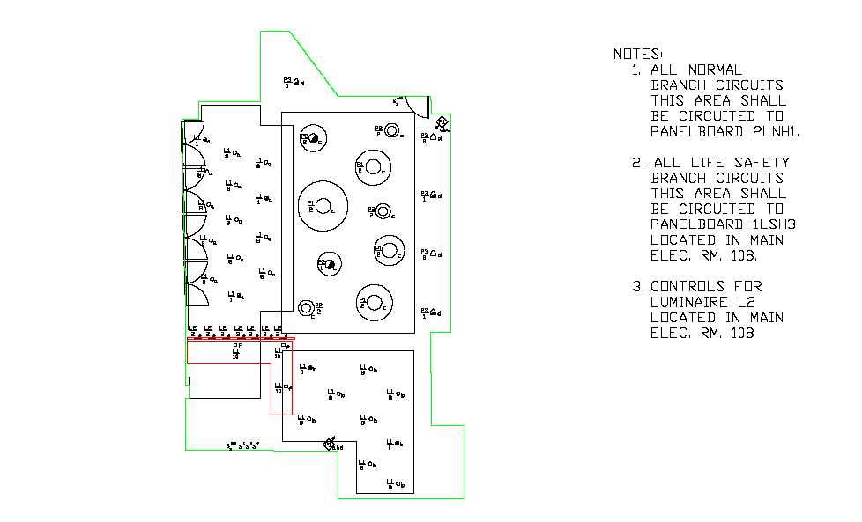
Fitness Center

For the fitness center I supplied two lighting design solutions, only one of which will be carried through in the electrical depth. I chose to complete circuiting for the more challenging of the two designs. For reference, this portion refers to the second lighting solution. In the existing power distribution plan, normal branch circuits for the fitness center lighting are circuited to panel 1LNH1 in positions 2,4, 6, 8, and 10. The existing panelboard schedule for Panel 1LNH1 is below, with the affected circuits indicated:
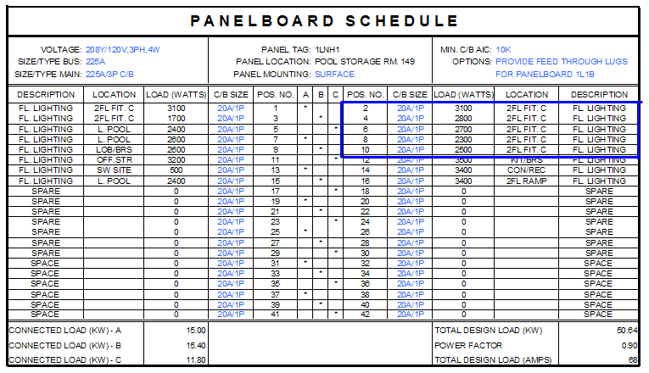

Modified Panelboard:
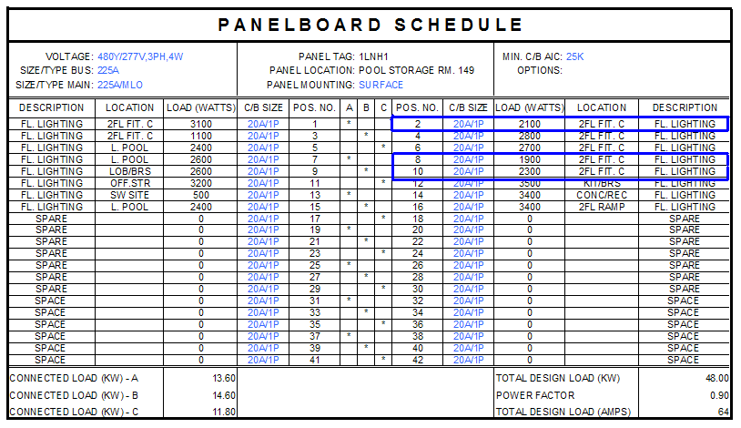
Design Amps: 64
Circuit Breaker Size: 70A
Feeder Size: (4) #6 THW Cu @ 75degC

Again, different choices could be made regarding the panelboard sizing, but to allow for growth the original decision was kept.

Life safety circuits in the original plan were circuited to Panelboard 1LSH2 in positions 1 and 2. The existing panelboard is below:

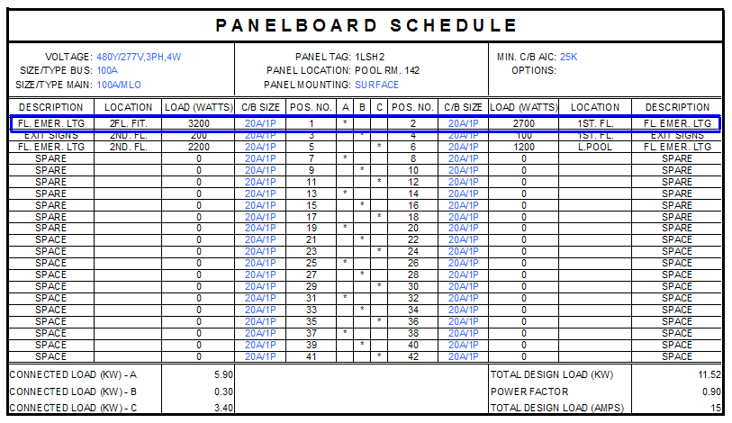

Modified Panelboard:
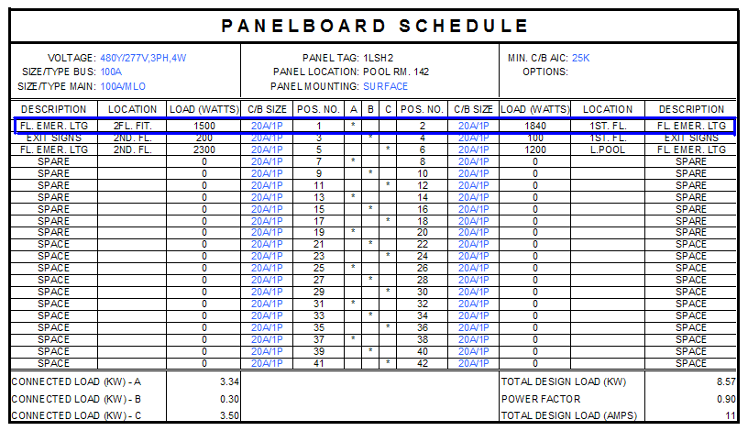
Design Amps: 11
Circuit Breaker Size: 15A
Feeder Size: (4) #12 THW Cu @ 75degC

Circuiting Layout for Upper Level Fitness Center:
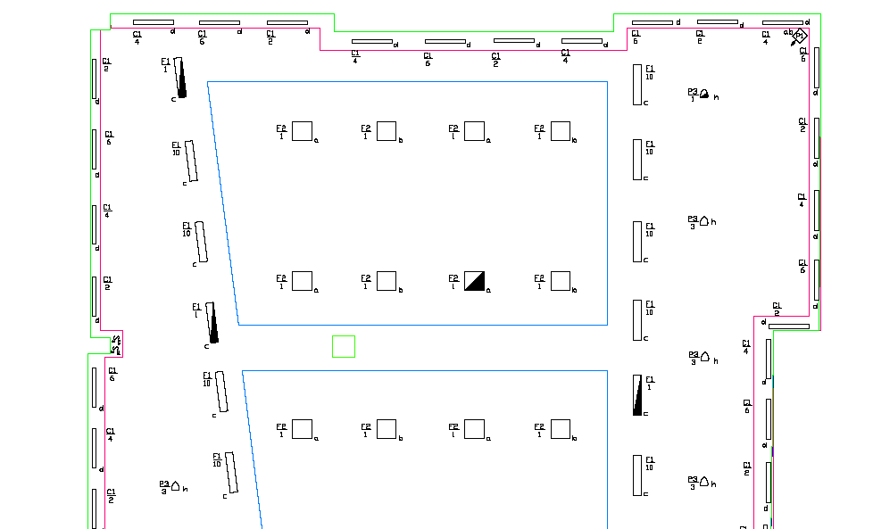
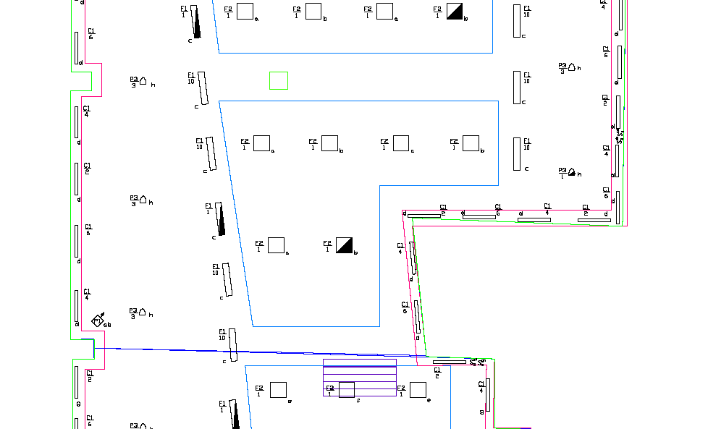
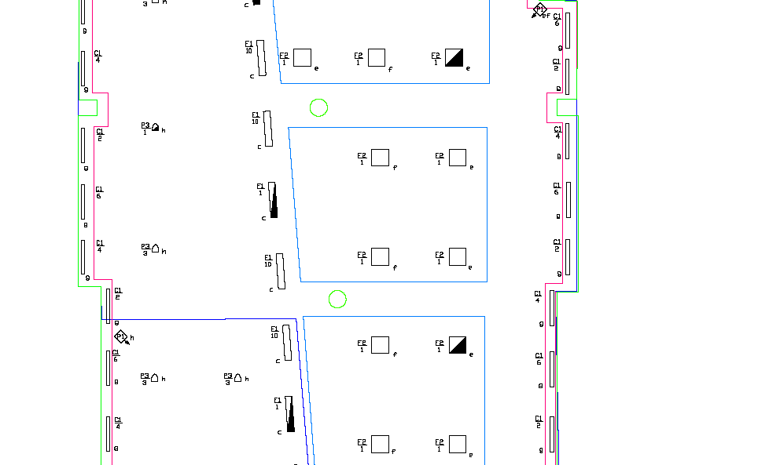
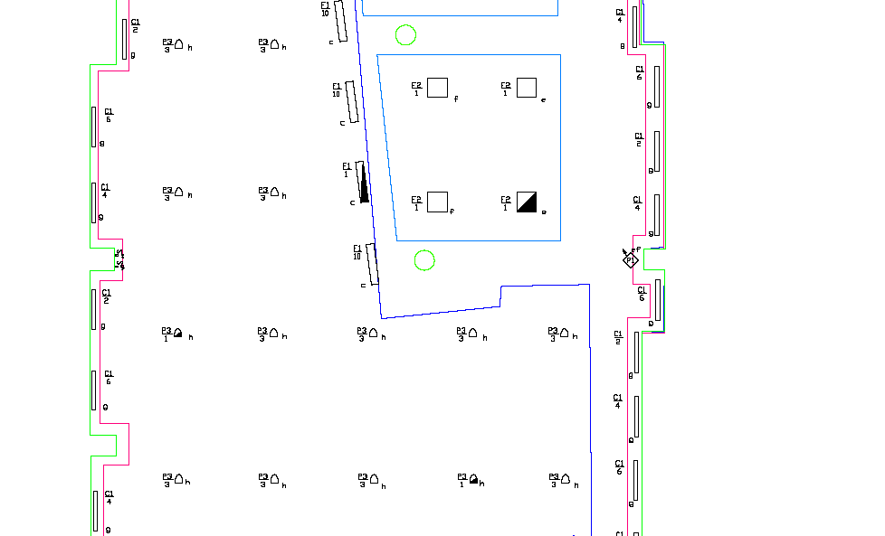
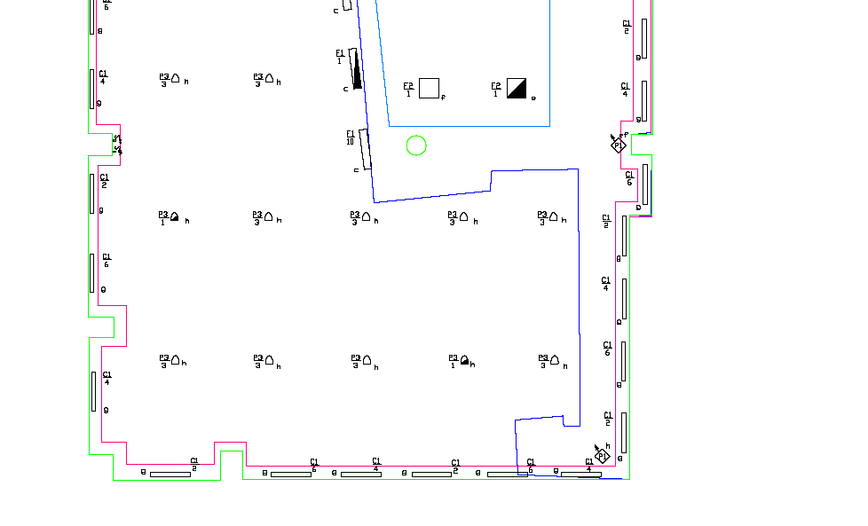

Circuiting for Lower Level Fitness Center:

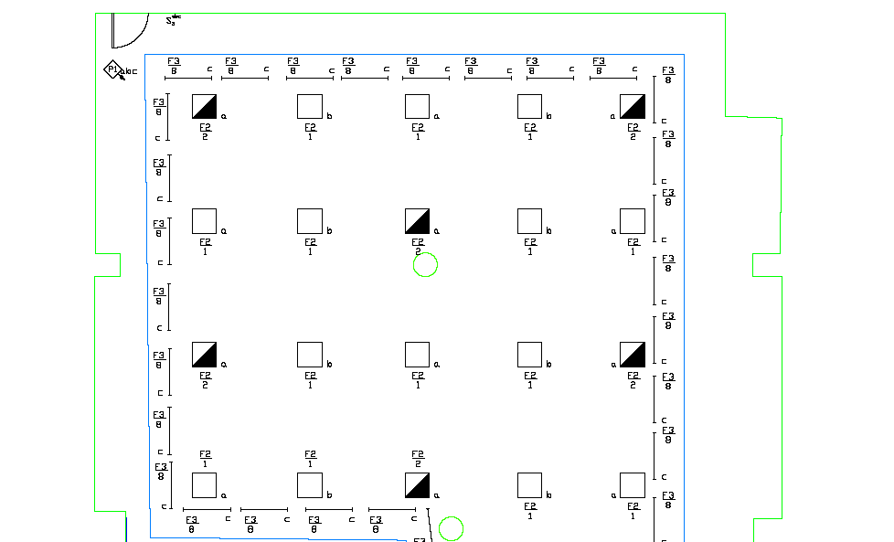
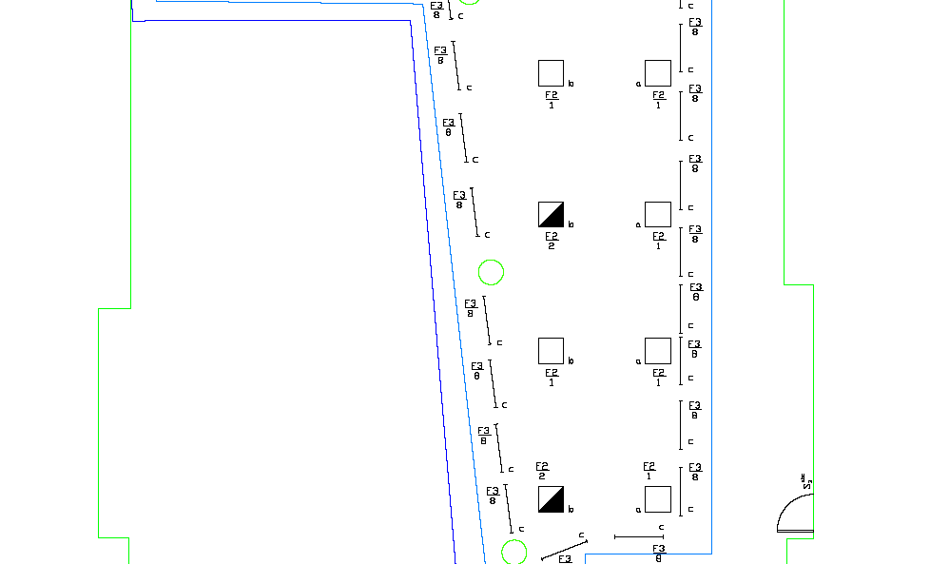
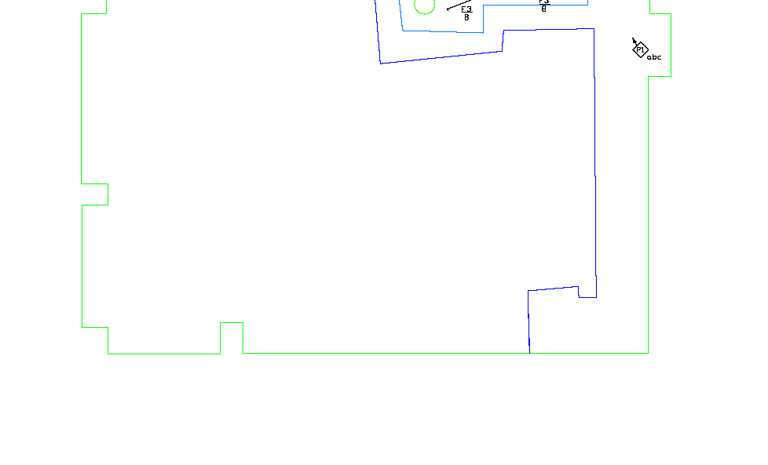
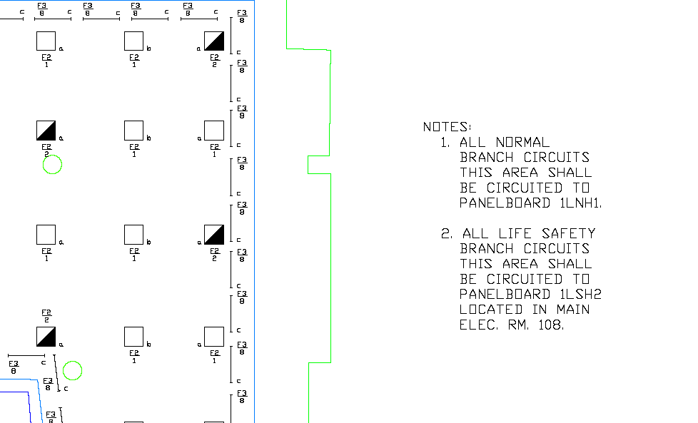

Note on fitness center lighting control – originally I had hoped to use this space as an exploratory model for photosensor control to incorporate daylight energy savings. By the time I had completed the work for the second lighting solution, there simply was not enough time to pursue this endeavor.

Concession Area

In the existing power distribution plan, normal branch circuits for concession area lighting are also circuited to panel 1LNH1 in positions 2 and 5. The existing panelboard schedule for Panel 1LNH1 is below, with the affected circuits indicated:

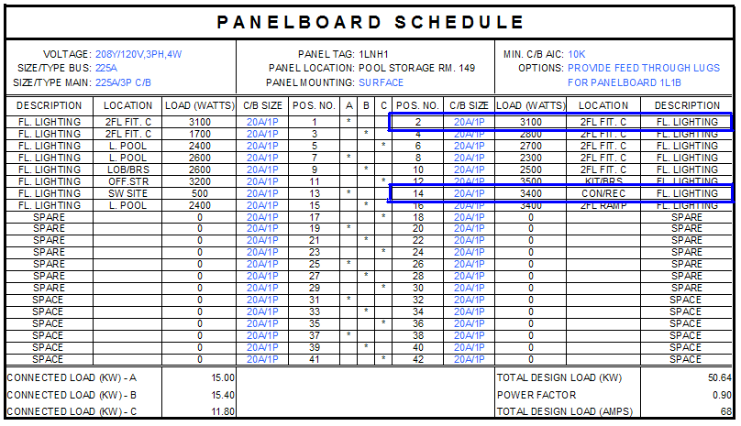

Modified Panelboard:
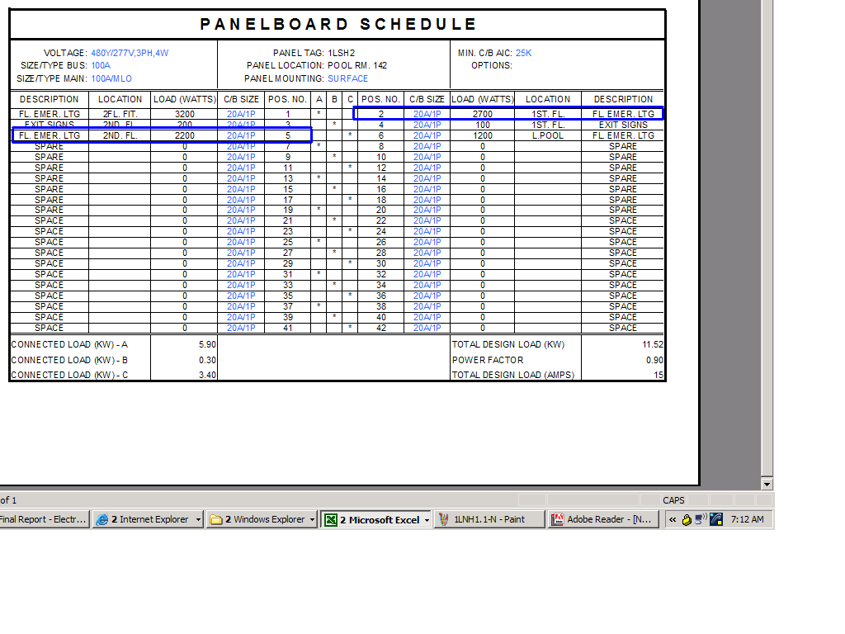
Design Amps (from Panelboard): 15
Circuit Breaker Size: 15A
Feeder Size: (4) #12 THW Cu @ 75degC

Life safety circuits in the original plan were circuited to Panelboard 1LSH3 in positions 2 and 5. The existing panelboard is below:

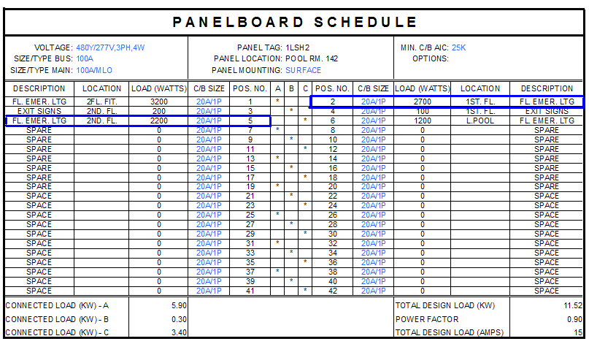

Modified Panelboard:
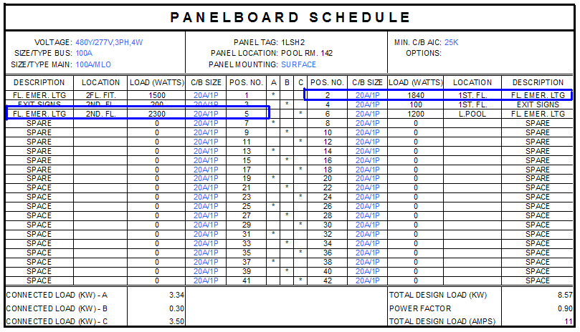
Design Amps: 11
Circuit Breaker Size: 15A
Feeder Size: (4) #12 THW Cu @ 75degC

Circuiting Layout for Concession Area:

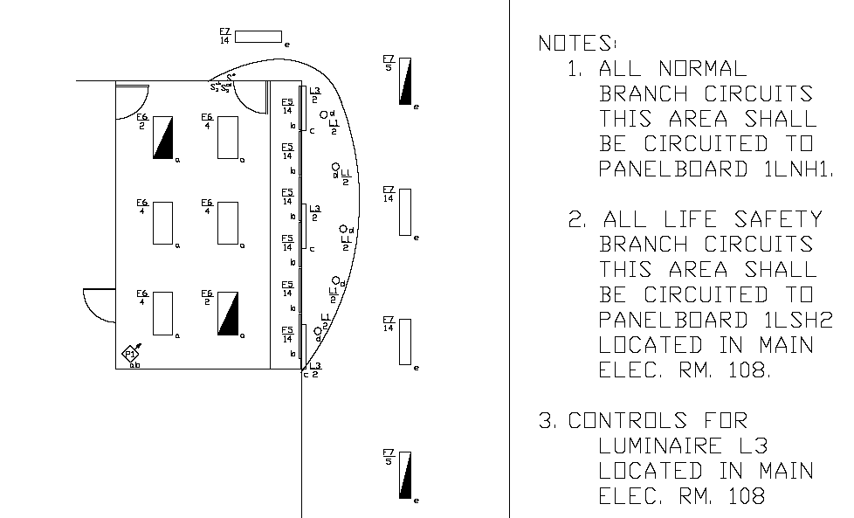

Tower

In the existing power distribution plan, the branch circuits that supply the tower lighting are circuited to panel 1LNH2 in position 5. For the new lighting, it was necessary to include a small data enabler as one of the controls, which was simply added as part of the lighting (the total load was about 10W) The existing panelboard schedule for Panel 1LNH2 is below, with the affected circuit indicated:

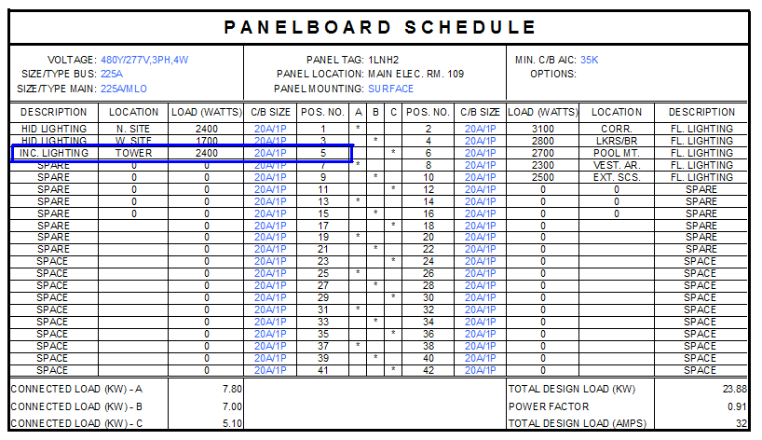

Modified Panelboard:
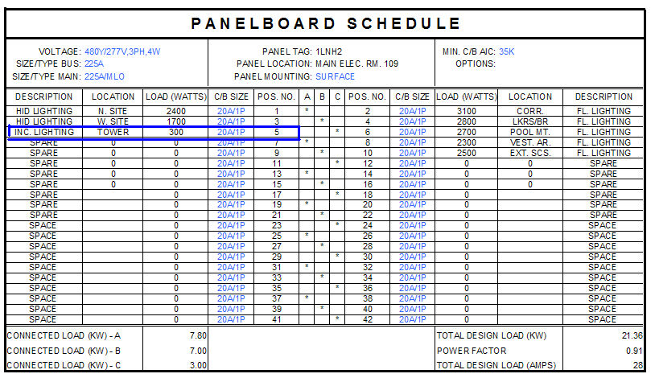
Design Amps: 28
Circuit Breaker Size: 30A
Feeder Size: (4) #10 THW Cu @75degC
No life safety lighting was existing or applied to the tower lighting design.

Circuit Layout for Tower:
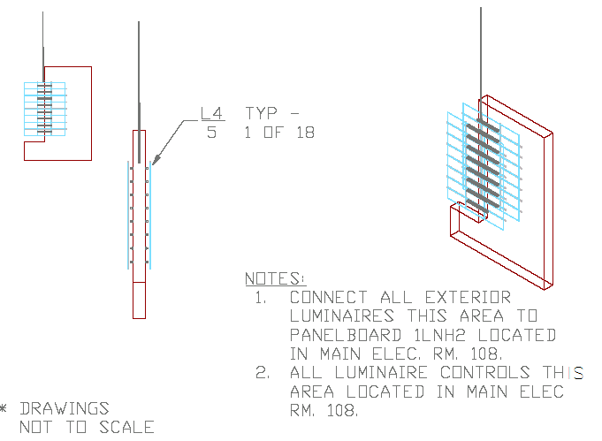
Conclusion

The overall general building load does not vary considerably from the existing load, but it is in general smaller, a credit to one of the overall design goals of an efficient design. No major stumbling blocks were encountered in this section of the project because, as mentioned earlier, the process is practical and straightforward.

Part 2: Copper to Aluminum Feeder Change Analysis

There could be many reasons to investigate changing copper feeders to aluminum, ranging from cost benefits to material properties to useability, etc. This study will briefly discuss the pros and cons of changing the feeders to aluminum.

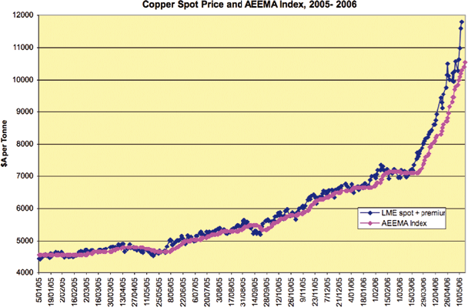
The first issue most parties would be concerned with is cost. The cost of copper has recently fluctuated but in general continues an upward trend. Aluminum is found in greater abundance and the price reflects that. Judging from the CostWorks estimating program, changing the feeders from copper to aluminum would have an initial cost savings of just over $17,000, shown by the following chart:

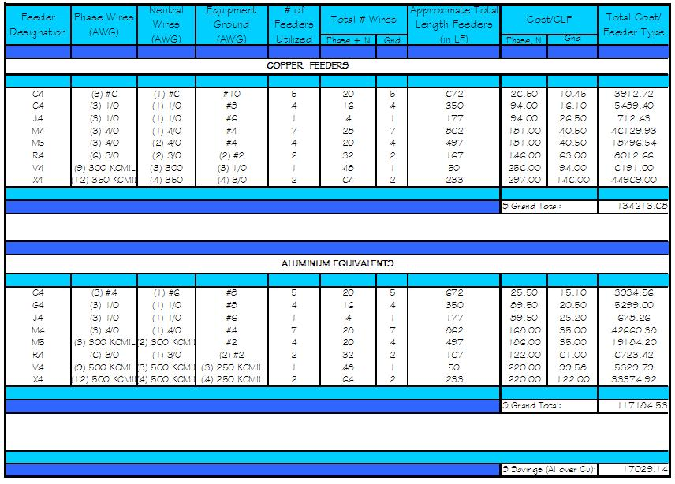

Unfortunately, first cost isn’t the only factor that must be taken into consideration when analyzing the overall benefits of this type of exchange. The equivalent aluminum feeders specified to handle the same load as the copper feeders are larger, and therefore have larger cross sections. This means that larger conduit will be needed to sheath these conductors, and in this case, ‘larger’ conduit is synonymous with ‘more expensive’ conduit. Therefore, immediately some of the savings retained through first cost disappear when the bill for conduit comes in. Additionally, there are some instances where the cost of aluminum exceeds that of copper, as shown on the chart in the comparison of the C4 type feeders. As conductors get smaller, the cost benefit of using aluminum decreases proportionally.
Certain material characteristics also give hints as to which material is more logical to use. The high coefficient of expansion is a troublesome characteristic of aluminums that can have devastating results. Because of the rate at which aluminum will expand in heat, connections become loose if they do not have the proper hardware to clamp them down. When electrical connections are not stable the risk of fire increases dramatically. Aluminum is lighter, so it can span further distances and cost less to transport, but the tradeoff is a less durable product. Copper is the stronger in tension and shear of the two materials and is more resistant to nicking and other issues that are always of concern in cable installation.
After mentioning of the material’s strength, it seems almost counterintuitive that copper is also the more workable material. Copper can be “bent farther, twisted harder, and pulled further” without breaking, which makes it easier to install than Aluminum. Furthermore, aluminum oxidizes in the presence of dampness causing many installations to have to be replaced or maintained more often than copper-outfitted systems.
It’s no wonder that it is not advised to use aluminum in electrical distribution systems. Using it where the electric flow is constant is ok, but at these two extreme locations in electrical systems (small scale wiring to individual devices and service entry) it doesn’t make too much sense to do so. As previously mentioned, aluminum loses its main advantage – cost – as size goes down. Regarding the service entry, this location is quite possibly the most important electrical run of conductor – does it follow to choose the material that may have to be serviced or replaced more often, knowing it’s drawbacks with workability, material characteristics, and corrosion-prone properties?
Conclusion

As far as the Gordon Fieldhouse is concerned, it seems overwhelmingly clear that choosing to use aluminum conductors in lieu of copper ones would not in fact be an advantageous route to embark upon. The main rationale for this decision is based on the fact that even though aluminum has some decent features, especially first cost, copper, on the whole, has a less expensive life cycle cost when preliminary price, installing, maintenance, repairs, and replacement are all taken into equal consideration.

Part 3: Energy Efficient Transformer Analysis

To supply the different voltages of power necessary at different locations on site, the Gordon Fieldhouse utilizes seven main transformers of various sizes. Cannon design has rigorous specifications regarding the quality of the equipment they use in a project, but energy efficiency, at least to the extreme that Powersmiths takes it, doesn’t play a leading role. To discover if high efficiency transformers would make enough of an impact to make a difference in the financial aspects of my building, I used the Powersmiths Energy Savings Payback Calculator to find out more information.

The first step in using the calculator is entering the base data for the project: what size and how many transformers the project has, equipment and load operations data, electric energy costs specific to the area, etc.

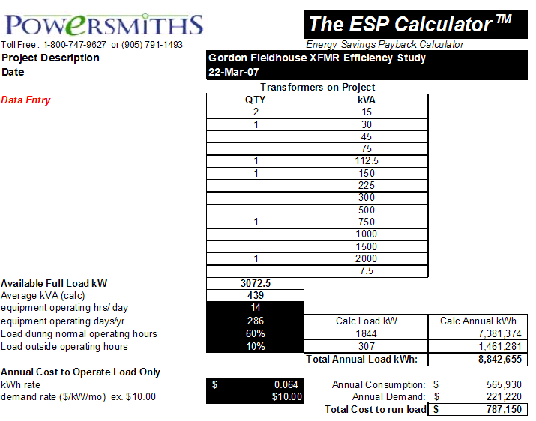
The resultant data reports the total annual load kWh as well as the total cost to run the load.

The next block requires input information regarding the existing transformers’ characteristics. Efficency inside and outside of normal operating hours as well as system performance statistics are necessary to make an accurate comparison of the two products.
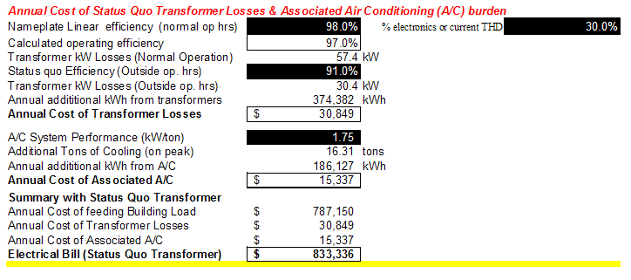
A typical electrical bill cost the owner might see puts a number on the efficiency of the current transformer set.

Finally, Powersmiths enters the last of the data for their high efficiency transformers and labels outside costs (like air conditioning) that are required for the system to operate at peak.
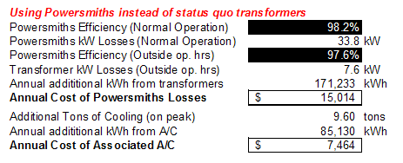

Once all the data has been entered, the calculator can present a numerical comparison between the two transformer options. It calculates the reduction of the electric bill as well as various forms of energy savings. Finally, it shows annual operating costs and the corresponding savings that can be achieved by using their product. A 20 and 32 year life cycle savings comparison is also provided.
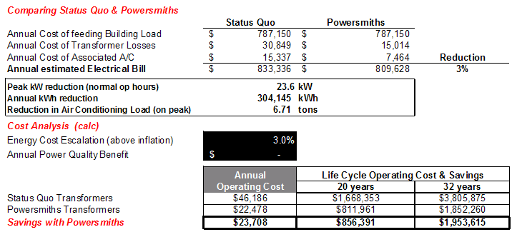

The last financial data specifically relevant to the individual building is presented through a final cost analysis. Through a comparison of the costs of the equipment coupled with the available energy savings calculated in previous steps, a payback on the total cost can be generated.
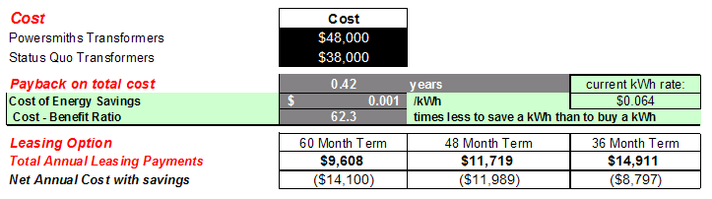

To add relevance and perspective to the numerical data, the final information given to the user is an environmental exchange analysis which reinforces the company’s ‘green’ awareness.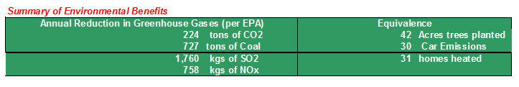

Conclusion

In the Fieldhouse’s case, using energy efficient transformers would provide a large financial advantage. With the immense energy savings, it would take less than half a year to pay off the excess it cost to outfit the facility with them In a campus building like this one, equipment is usually aimed to “be done once and done right”, and judging from the life cycle operating cost and savings, this product would uphold that mentality. Other than the initial cost, which disappears before 6 months have passed with the system, there seems to be no readily apparent reason why switching to high efficiency transformers would be detrimental.

Part 4 – Protective Device Coordination Study

Device Coordination

To test a path through the protective devices of my system and see if they are coordinated to one another, it was necessary to see if the circuit breaker trip curves overlaid for a basic coordination check. I began with one of the lighting fixtures in the concession area of the Fieldhouse, which is circuited to Panelboard 1LNH1 and is protected by a 20A circuit breaker. The panel is connected directly to the 480Y/277V switchboard, and is protected by a 70A circuit breaker (using the breakers I sized). The final circuit breaker in this coordination study is the 225A CB in the switchboard. I obtained the trip curves from Cutler Hammer and in was able to superimpose them on top of each other to make sure the 20A circuit breaker went first, the 70A second, and the 225A last. Because this is the case, the devices are coordinated.

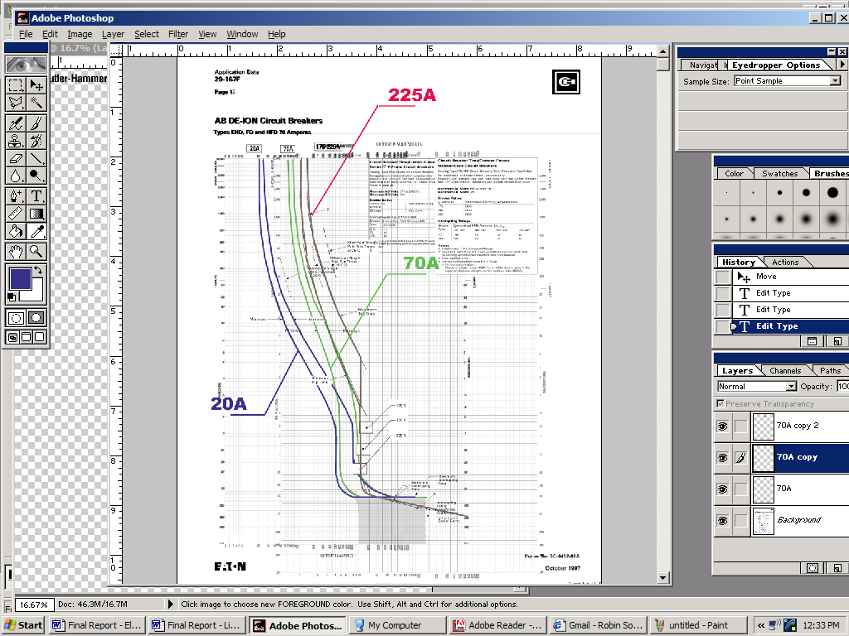
Short Circuit Current Calculations

In order to perform the calculations on short circuit, the available short circuit current from the utility is necessary to know. Unfortunately, when I tried to get this information, I hit a dead end. Attached is the correspondence documenting my efforts.

From: Sara Schonour [mailto:sjs345@gmail.com]
Sent: Wednesday, April 04, 2007 12:30 AM
To: Charles Bruno
Subject: More questions!
Hi Chic -
a few more (hopefully)quick questions for you:
I'm looking for the kWh utility rate you pay for electricity to the fieldhouse (the drawings show that the fieldhouse is fed from a campus feeder, so that would be fine), as well as the demand rate ( in $/kW/mo).
what is the available short circuit currentfor the fieldhouse, and where in the system is this located?
thanks again for all your help, and I hope you're having a great week!
Sara

________________________________________
From: Charles Bruno
Sent: Wednesday, April 04, 2007 5:44 AM
To: 'Sara Schonour'; Dave Harris
Subject: RE: More questions!
Hi Dave,
Can you help Sara regarding below.Sara is a Penn State student doing her thesis on the fieldhouse through Cannon have been helping her on my favorite bldg and hope that you can help or guide her regarding her questions.Let us know ASAP
Thanks
. . . Chic
________________________________________
Morning Gary,
What do we pay per KWH (6.42 cents per KHW?)
What do we pay for demand (KW)?
Hi Sara,
If I follow your question correctly (if I missed the mark, let me know), for available short circuit current, there are two answers because there are two services, I am assuming your interest is in the building. The campus distribution system is 12,470 volts (3 ph).
The distribution system feeds a set of three single phase liquid cooled transformers to make the 480/277 service (Delta primary, Wye secondary). The rating for each transformer is...12,470/277v, 750kva, 6.6%IZ giving a 2,250kva 277/480 three phase Wye service. I do not have a X/R value. This is fed to low voltage distribution switchgear that has a 3,000 amp buss, 3,000A circuit breaker frame, with the breaker set at 3,000 amps.
The distribution system feeds a second set of three single phase liquid cooled transformers to make the 208/120v service (Delta primary, Wye secondary). The rating for each transformer is...12,470/120v, 250kva, 6.4%IZ giving a 750kva 208/120 three phase Wye service. Again, I do not have a X/R value. This is fed to low voltage distribution switchgear that has a 3,000 amp buss, 3,000A circuit breaker frame, with the breaker set at 2,500 amps.
Each switchgear has an assortment of distribution breakers feeding distribution panels and then branch panels, or major HVAC equipment.
Let me know if you need more info.
Take Care,
Dave H
Dave Harris
RIT-FMS
Phone: 585-475-2060
Fax: 585-475-7332
E-mail: 47@MAIL.RIT.EDU
Conclusion

If I had the available short circuit current and the X/R ratio I would have proceeded to follow the Direct (Ohmic) method to ultimately find the available short circuit current on the transformer secondary and at the switchboard.

